TUNISIA | Engaging Tunisian Youth to Achieve the MDGs (MDGF- 1930)
 | Youth, Employment, and Migration
Total Budget: | USD 3,115,000
Budget by Agency: | IOM: 440,305  UNDP: 721,874  FAO: 678,863 |  |  | ILO: 615,159  UNIDO: 658,799
Participating Gov. Entities: | Ministry of Employment and Professional Insertion of Youth  Ministry of Agriculture  Ministry of Industry and technology  Ministry of Secondary education  Government of Kef, Gafsa, and Grand Tunis
Start Date:  Est. End Date:  Extension Date: | 13 May 2009  13 May 2012
Disbursements: | First Disbursement: |  | 7 May 2009 |  |  |  | USD 901,467
 | Second Disbursement: |  | 18 October 2010 |  |  |  | USD 1,036,303
 | Third Disbursement:
In Brief: | The overall objective of the programme is to support Tunisia in its efforts to develop and enhance regional capacities in migration-prone areas, through the sustainable creation of decent jobs and the promotion of local competencies in the pilot regions of El-Kef, Gafsa and Tunis. The programme proposes differentiated interventions adapted to the varying needs of two target groups i) unemployed university graduates and ii) unemployed unskilled youth. This will be achieved through: 1) enhancing national and regional capacities to develop, implement, coordinate and monitor regional employment and migration policies and programs; 2) innovative entrepreneurship promotion and job creation schemes including a circular migration mechanism for the targeted youth of the pilot regions. The UN will implement the programme through a network of governmental and non-governmental partners, with capacity building cross-cutting all interventions.
Outcomes:  - Youth and employment migration policies and programs better adapted to the labour market trends and the specific needs of unemployed university graduates and unemployed low skilled youth in the three target regions (Tunis, El Kef, Gafsa).  - University graduates have better access to decent job opportunities and engage in the creation of SMEs in the target regions (Tunis, El Kef, Gafsa).  - Low skilled young men and women from El-Kef, Tunis and Gafsa have access to better Employment and migration support services and decent job opportunities. |  | 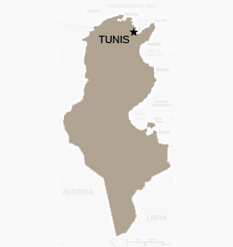
Regions of Intervention: | - Tunis, El Kef, and Gafsa
MDGs | MDG1 T1.B
Beneficiaries | Direct |  |  |  | Indirect
- No. Institutions
- No. Women
- No. Men
- No. ethnic groups

Project coordinator: Vacant
RCO Focal Point:
Web page:
Status | The potential of this joint programme is tremendous, unfortunately, the joint programme is lagging behind and suffers from the slow start- up phase of the joint programme, the experienced difficulties on coordination of UN agencies and government counterparts and the political events of January 2011. Progress to date has mainly focused on strengthening the internal institutional capacities through specific studies, technical assistance, development of new methodologies for employment trend analysis.  The mid-term evaluation reveals serious deficiencies in the operationalization of the joint programme and strongly recommends that the joint programme is reformulated to take account of on the ground capacity, national priorities and counterpart engagement. A no-cost extension has also been recommended to overcome delays and constraints. he improvement plan following the mid-term evaluation has yet to be finalized and the programme has not submitted the monitoring report for the first semester of 2011.
Estimated financial execution status as of the June 30, 2011 biannual report: | 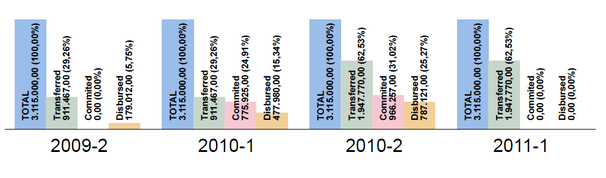
Main Achievements:  (by expected outcomes) | Not reported
Observations
Paris Declaration | Leadership of national and local governmental institutions:  The implementation of this joint programme has allowed a process of decentralization to be initiated that should evolve alongside the implementation of the different programme activities. Regional steering committees headed by the respective governors of the three target regions have been trained to this effect. Civil society representatives also sit on these committees and contribute to the various missions and programme actions. The establishment of regional committees has also been important to ensure the ownership of the programme initiatives by the regional authorities and sectoral ministries represented at this level.  However, Local authorities and the regional committee in El-Kef and Gafsa expressed their frustration for not being kept abreast of the status quo of the JP and the long intervals between project activities.
 | Involvement of CSOs and citizens:
Alignment and Harmonization:
Among Tunisia’s top national priorities are: increasing of the human development index of the country, generating employment and promoting human resource development, increasing opportunities for the youth and increasing the country’s productivity. The joint programme clearly responds to national priorities and it is framed within the President’s Electoral Programme 2009-2014 and the National Development Plan 2011-2016.

It has the potential to impact have a clear impact on MDG1 in the selected areas of intervention. The Joint Programme is also viewed by other partners in the development community such as the European Commission as an important innovative initiative that is expected to gather additional baseline information, test new public-private partnerships to generate employment and explore new vocational training opportunities.

 | Innovative elements in mutual accountability:
Delivering as One | Innovative elements in harmonization of procedures and managerial practices:
Role of the RCO and synergies with other MDG-F JPs:
The JP contributes to the UNDAF’s most important priorities for the UN in Tunisia. The RC is committed to supporting the MDG-F initiative. Certainly this joint programme has provided a good platform for UN agencies to work together and promoted joint planning with clear roles and responsibilities.

Inter-agency coordination:

Differences within the participating agencies in terms of representation or the institutional capacity necessary to manage their respective programme components has led to differences in implementation speed. Indeed, the nature of some agencies’ activities requires a rather regular presence in intervention areas in order to accelerate implementation.
Sustainability (concrete actions and strategic partnerships) | Sustainability Plan in place? No  For capacity-building institutional support activities of which the impact on the entities affected goes beyond the envisioned timeframe of the Joint Programme, participating agencies have adopted approaches involving institutional partners such as the private sector and associations. This approach is intended to guarantee the sustainability and permanency of the effects of the Joint Programme.
Innovation and Scale-up

External Factors and mitigation | Unfavourable political climate under which the JP has been functioning from its commencement until the present. Prior to the revolution of 14 January 2011, for example, the MOE imposed conditions and restrictions on the JP. Currently, the country is in a transitional phase with a lot of uncertainties in anticipation of the upcoming elections in October 2011. Many Tunisians migrants who had been working in Libya have also returned due to the crisis there and thus have compounded the problem of unemployment.
Communication and Advocacy | C&A plan in place? No  In March 2010, the YEM Joint Programme was presented to the President of the Republic during a ministerial meeting on youth employment.
M&E | The joint programme has not submitted the monitoring report for the period January-June 2011.  The JP is that it lacks an effective monitoring and evaluation system. Each UN agency oversees its own monitoring activities and uses its own format. This information is then forwarded to the PC who incorporates it into the JP monitoring reports. These reports are confusing for several reasons; (i) the JP indicators are vague and do not measure the project’s progress but rather describe a list of activities performed during a certain period; (ii) the PC does not have monitoring and evaluation experience; (iii) the monitoring reports from each agency are not uniformly prepared, making this a more challenging task for the PC. As a result, the JP does not have follow-up mechanisms to verify the quality of the products, punctuality of delivery and progress of the JP towards achieving the envisaged results.
Missions from MDG-F Secretariat: | Date: May 2010 | Members: Sara Ferrer Olivella
Mid Term Evaluation: | Evaluator: Mouna H. Hashen  Period: May-October 2011  Link to final report and improvement plan http://www.mdgfund.org/jointprogrammidtermevaluation

